Git and Github Notes

Any Javascript, jQuery or jQuery UI questions?

Review syllabus, mostly java from here on out

Using video helps me remember everybody’s contribution during the meeting. I provide input on corporate program.

Install GIT, see Jacob’s notes <https://docs.google.com/document/d/1xBvN1kq7ahhM1IA9CjSWpLgyzSWn8XjbszJAwNd3hvU/edit>

Csiebsen genes10s

What is version control, why do you need it?

Stepping on each other’s code

Who made this change, when and why?

Boss wants to remove something you coded 2 months ago.

Allows branching for sub tasks.

Create TTS/Day 4 – Git and Git-Hub

Install – <http://git-scm.com/download/MAC> or win

Right click 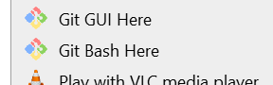

Git version

Git config –global user.name ‘Chuck Siebsen’

Git config –global user.email ‘csiebsen@yahoo.com’

Create files to add

Touch index.html

Touch myCSS.css

Open VS and add code to each file

Initialize git and add files

Git init (hidden git directory, never have to see)

Git add index.html

Git status (Explain the output)

Git rm –cached index.html

Git add *.html

Git rm –cached index.html -- remove it again

Git add *

Git status

Modify index.html

Git status (explain output)

Git add *

Git status

GIT commit

Git commit // the harder way

I

Type text or uncomment # for text to commit

Escape

:wq

Git Status

Create new fie myApp.js

Git Add .

Git commit -m “My change description”

Clear

Add a directory with 2 files

Add and commit

Ignoring

// why would you not want to commit one of your files?

Touch .gitignore

Touch Output.log

Edit .gitignore an add Output.log

Git add .

Git status

Branching

// Why would we branch?

// don’t want to add to repository without finishing some new functionality

// maybe don’t want to add for some other reason, not approved yet, waiting for something else first, need to unit test

// separately

Git branch mybranch

// still on master branch

Git checkout mybranch

-- create and modify some files

Git add .

Commit -m “new branch changes”

-- switch to master and see changes disappear

Git checkout master

--Merge in mybranch

Git merge mybranch

-- should see changes now

Git push

GitHub

Github.com login, create login if you don’t have one

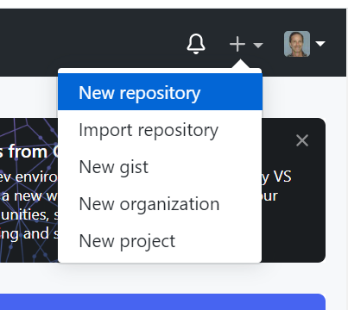

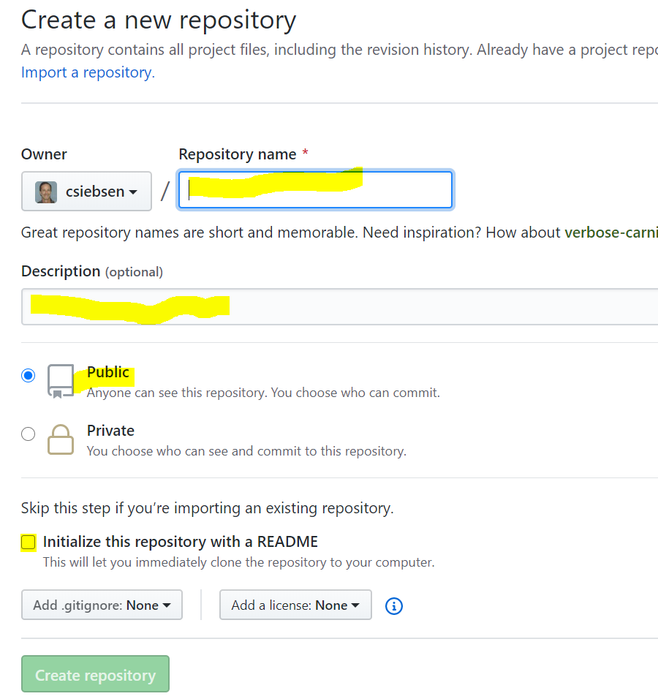

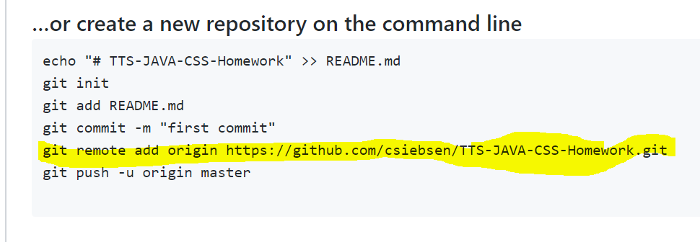

// run above command from Git Bash

Git remote // shows none

Git push -u origin master

Login to Github

In VS Touch readme.md // mark down file

#TTS Java example

Sometext

Git add .

Git commit -m ‘added readme’

// doesn’t show yet

Git push

// see files in github

Git remote

GitHub go to github and open a file, click the link to show changes, blame etc.

Cloning a repository

Git clone (the link to repository)

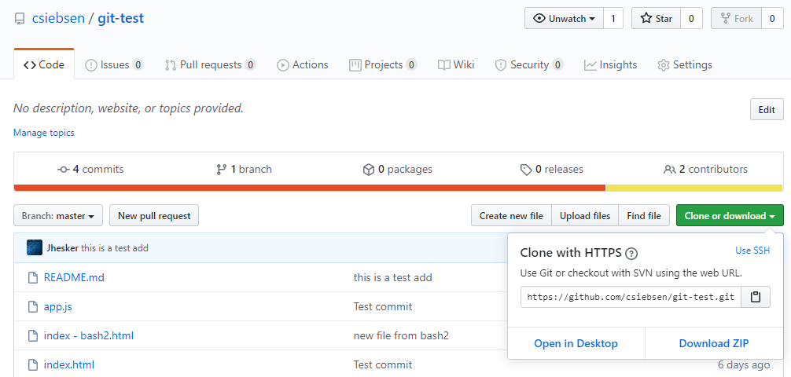

// have them clone their repository to a different directory

Cd to the new sub directory

// add a file, commit push

// see the file in GIthub

// git pull in the original directory

**Challenge GIT Git-Hub**

create branch // Git branch xbranch

//git checkout xbranch

add a couple files

//git add .

//git commit -m “”

// checkout master

merge the branch back to the master

push updates to Github

examine the results

In Github Go to settings --> manage access --> invite collaborator --> [jhesker@gmail.com](mailto:jhesker@gmail.com)

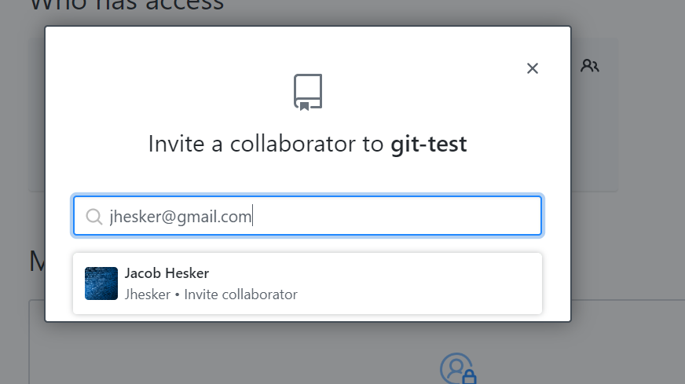

// cloning my repository

Create csiebsen directory and open Bash in it

$ git clone <https://github.com/csiebsen/git-test.git>

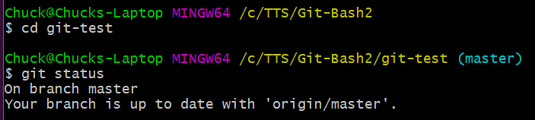

// if that works have them add a file

// add a file myName.html , commit push

Git pull to see other student’s names

## Git/Github Homework

1. Go through the GitHub Training available at <https://try.github.io/>
2. Practice collaborating on a ruby program or website with a partner using Github and pull requests.

Homework to hand in, just tell us what you did.

If there’s too much time left start on Java? More challenges with Git?

What happens if you change the same file in 2 separate repositories and push?

**Make sure everyone had Eclipse setup and can run a helloWorld Java program**